THIRD GRADE CONSUMABLE LIST
Use hyperlinked ISBN numbers below to be redirected to purchase sites
Book Title | ISBN
Pinocchio | 978-0141331645 | 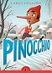
Little House on the Prairie | 978-0064400022 | 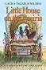
The Lion, The Witch, and the Wardrobe | 978-0064471046 | 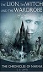
The Little Prince | 978-0156012195 | 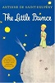
The Real Thief | 978-0312371456 | 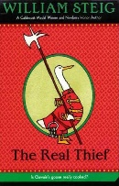
The Trumpet of the Swan | 978-0064408677 | 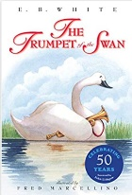
Harp and Laurel Wreath (One per student) | 978-1586176914 | 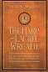
Les Loustics 2 | 978-2011559067 | 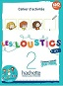
3rd Grade Student Bundle:  Blue Spalding Notebook  Math Workbooks  Birthday Celebration Treats  Special Events/Field Trips  Student Planner | Configio Parent Portal
Well-Ordered Language 1A *Revised Edition | 978-1600512858 | 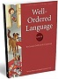
Well-Ordered Language 1B | 978-1600512919  9781600512919 | 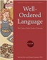
Edukit | Edukit | 

(multiple links provided for your shopping convenience – please ensure your ISBN matches)

