Second Grade
Use hyperlinked ISBN numbers below to be redirected to purchase sites
Book Title | ISBN
A Cricket in Times Square | 978-0374390402 | 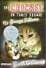
Boxcar Children | 978-0807508527 | 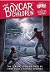
Charlotte's Web | 978-0064400558 | 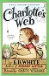
D'Aulaires' Book of Greek Myths | 978-0440406945 | 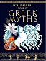
Abraham Lincoln | 978-1893103238 | 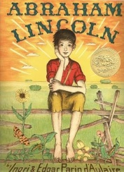
Little House in the Big Woods - Laura Ingalls Wilder | 978-0060581800 | 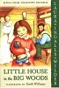
The Hundred Dresses | 978-0152052607 | 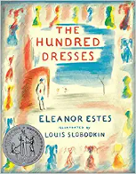
Harp and Laurel Wreath (One per student) | 978-1586176914 | 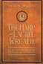
Les Loustics 1 (New families to ACV ONLY) | 978-2011559050 | 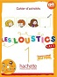
2nd Grade Student Bundle:  Spalding Paper  Pink Spalding Notebook  Math Workbooks  Birthday Celebration Treats  Special Events/Field Trips  Student Planner | Configio Parent Portal
Phonogram Cards - Classroom Set of 87 (One set per family) | Spalding Education | 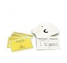
Edukit | Edukit | 

