KINDERGARTEN CONSUMABLE BOOK LIST
Use hyperlinked ISBN numbers below to be redirected to purchase sites
Book Title | ISBN
Mouse Soup | 978-0064440417 | 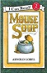
Mouse Tales | 978-0064440134 | 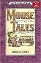
Harp and Laurel Wreath (One per student) | 978-1586176914 | 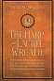
Kindergarten Student Bundle:  Phonogram Cards  Pink Notebooks  Math Workbooks  Birthday Celebration Treats  Special Event/Filed Trips | Configio Parent Portal
Edukit | Edukit | 

