FOURTH GRADE CONSUMABLE LIST
Use hyperlinked ISBN numbers below to be redirected to purchase sites
Book Title | ISBN
Carry On, Mr. Bowditch | 978-0618250745 | 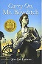
D'Aulaires' Book of Greek Myths | 978-0440406945 | 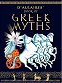
Prince Caspian | 978-0064471053 | 
Robin Hood | 978-0141329383 | 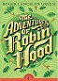
The Princess and the Goblin | 978-0141332482 | 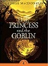
The Wonderful World of OZ | 978-0486291161 | 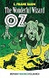
Les Loustics 2  *For NEW families only who did not purchase in 3rd grade* | 978-2011559067 | 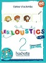
Growing Your Vocabulary; Level 4 | 978-1580498708 | 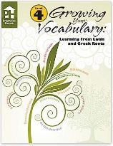
Dictionary/Thesaurus Set | 978-1596951693 | 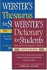
Harp and Laurel Wreath (One per student) | 978-1586176914 | 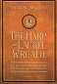
Well-Ordered Language 2A | 9781600513039  978-1600513039 | 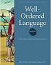
Well-Ordered Language 2B | 9781600513107  978-1600513107 | 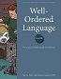
4th Grade Student Bundle:  Math Workbooks  Birthday Celebration Treats  Special Events/Field Trips  Student Planner | Configio Parent Portal
Edukit | Edukit | 

(multiple links provided for your shopping convenience – please ensure your ISBN matches)

