FIRST GRADE CONSUMABLE LIST
Use hyperlinked ISBN numbers below to be redirected to purchase sites
Book Title | ISBN/LINK
A Bargain for Francis | 978-0064440011 | 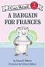
Frog & Toad Boxed Set | 978-0060580865 | 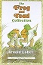
Owl at Home | 978-0064440349 | 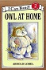
Three Tales of My Father's Dragon | 978-0679889113 | 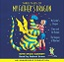
Bears on Hemlock Mountain | 978-0689716041 | 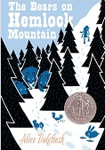
Harp and Laurel Wreath (One per student) | 978-1586176914 | 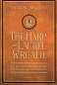
Les Loustics 1 | 978-2011559050 | 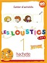
First Grade Student Bundle:  Pink Spalding Notebook & Paper  Writing with Ease, student pages – Revised Edition  Math Workbooks  Birthday Celebration Treats  Special Events/Field Trips  Student Planner | Configio Parent Portal
Edukit | Edukit | 

