FIFTH GRADE CONSUMABLE LIST
Use hyperlinked ISBN numbers below to be redirected to purchase sites
Book Title | ISBN
Across Five Aprils | 978-0425182789 | 
The Secret Garden | 978-0064401883 | 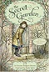
Voyage of the Dawn Treader | 978-0064471077 | 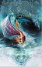
Where the Red Fern Grows | 978-0440412670 | 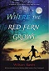
Dictionary/Thesaurus Set (New families ONLY) | 978-1596951693 | 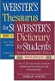
Harp and Laurel Wreath (One per student) | 978-1586176914 | 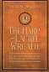
Well-Ordered Language 3A | 9781600513183  978-1600513183 | 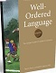
5th Grade Student Bundle:  Math Workbooks  Birthday Celebration Treats  Special Events/Field Trips  Student Planner  5th Grade T-shirt (Will get student sizes at a later date) | Configio Parent Portal
Growing Your Vocabulary; Level 5 | 978-1580498715 | 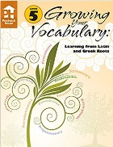
Edukit | Edukit | 

(multiple links provided for your shopping convenience – please ensure your ISBN matches)

