Archway Veritas
December 12, 2021
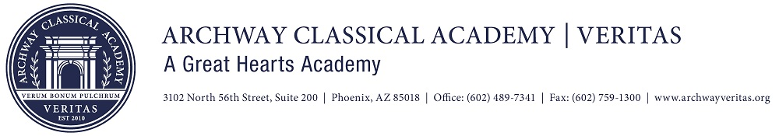
Dear Parents,
Happy Holidays! After a one-and-a-half-year hiatus, it was wonderful to see so many families at the Winter Concerts. Your spirts were high and your support of our programs contagious. The children were clearly excited to sing for you. I saw toes tapping, heads bobbing and plenty of smiles.
Wednesday, January 5th is Poetry Day at Archway Veritas. Each class will recite a poem in the Lund Auditorium in front of their peers. Regular classes will resume afterwards with a focus on poetry. The importance your children place on preparing for their poetry recitation will be on full display on our first day back to school. For the past several weeks teachers have parceled out the memorization of a lengthy poem. The final few days of winter break provides an opportunity for our students to not only ensure their poem is memorized, but to work on cadence, pitch, and the ebb and flow of poetry that so clearly sets the mood. Practice is the key to success!
Why do our students study poetry? Is it just to torment them with the memorization of lines to regurgitate at a moment’s notice? Great Hearst is very intentional with its inclusion of poetry in its classical, liberal arts curriculum. Students assimilate to the patterns and sequences when reciting poetry. Building stamina in memorization gives students an advantage when learning a new language, studying mathematics and in reading comprehension. Poetry instruction provides opportunities for students to learn first-hand the power of words. Poets purposefully select the nouns, verbs, adjectives, and adverbs to capture the mood, convey the message, and emotionally connect with the reader. Imagine the rich conversations that are held in our classrooms as students identify the words that resonate with them. A well-crafted phrase can make a student understand an experience in a new way. Well selected poetry provides students’ a multitude of sensory experiences with nature, history, and the emotions of excitement, sorrow, worry and joy. Most importantly, good poetry exposes our students to Truth, Goodness and Beauty – often viewed as abstract, but in the study of poetry provides a concrete connection.
I wish each family a happy and healthy holiday season!
In partnership,
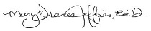
Dr. Jeffries

School Dates to Note
- December 15th - 17th: Half-Day Dismissal - 12:00pm
- December 17th: Food Truck Friday; Dough Riders
- December 20th - January 4th: Winter Break - No School
- January 5th: School Resumes

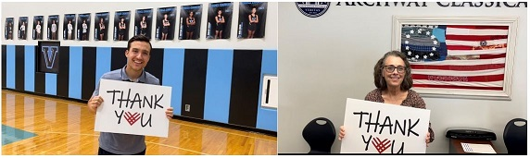
Because of you, Archway Veritas raised the most out of ALL 21 Great Hearts Schools on Giving Tuesday!
The #GivingTuesday campaign brought in over $35,000 for Community Investment!
We are now at 39% participation and 87% to our goal.
(including pledges that have not been fulfilled)
Our Archway Veritas Community showed up in an amazing way for #GivingTuesday, and I cannot thank you enough!
You can make a gift today by clicking here or by contacting Teresa Hennessee in the Academy Giving Office at (602) 489-7341 x. 206318.

Semester 2 Clubs
Semester 2 Club offerings can be be found by following the link below for you to view (and plan) your child's afterschool activities.
Registration is open January 3rd (9:00am) - 12th.
Clubs will begin the week of January 17th.
Click HERE to be redirected to Club website.
After-school clubs are offered Monday - Thursday. After-school clubs are not offered on Fridays. We hope that you appreciate the clubs that we have available, however we are still hoping to add a few more.
Clubs fill up quickly - be sure to reserve your spots! There will be no registration after January 12th - Mark your calendars!

The Lost and Found bin will be cleaned out over Winter break. Any items left in the bin after December 17th will be donated.

Message from the Health Office
In accordance with Arizona State Law (A.R.S 15-872), students must have proof of all required immunizations, or a valid exemption in order to attend school.
It is also a requirement for all students who turn 11 years old to receive the Meningococcal and Tdap vaccine within 4 days of their 11th birthday. The Meningococcal vaccine provides protection against the meningitis bacteria and the Tdap vaccine provides protection against tetanus, diphtheria and pertussis (whooping cough).
For any questions, please reach out to Nurse La Perna jlaperna@archwayveritas.org

Archway Veritas Parent Service Organization (AVPSO)
The Archway Veritas Parent Service Organization (AVPSO) invites you to join our family directory. The AVPSO uses this list to send bi-weekly email updates about events, volunteer opportunities, and more.
Please click here to update or activate your account.

Amazon Smile
You can still support our school by purchasing from Amazon!
1. Go to https://smile.amazon.com/
2. Select your charitable organization (Archway Veritas)
3. Bookmark https://smile.amazon.com/
*Hint: It works best on your desktop

Quick Links:
Family Handbook | Family Resources | Amazon Smile | Archway Veritas Board Meeting | Phonogram Videos

